38. Trigger Patterns and Child to Parent Traverse - 24 May 2022

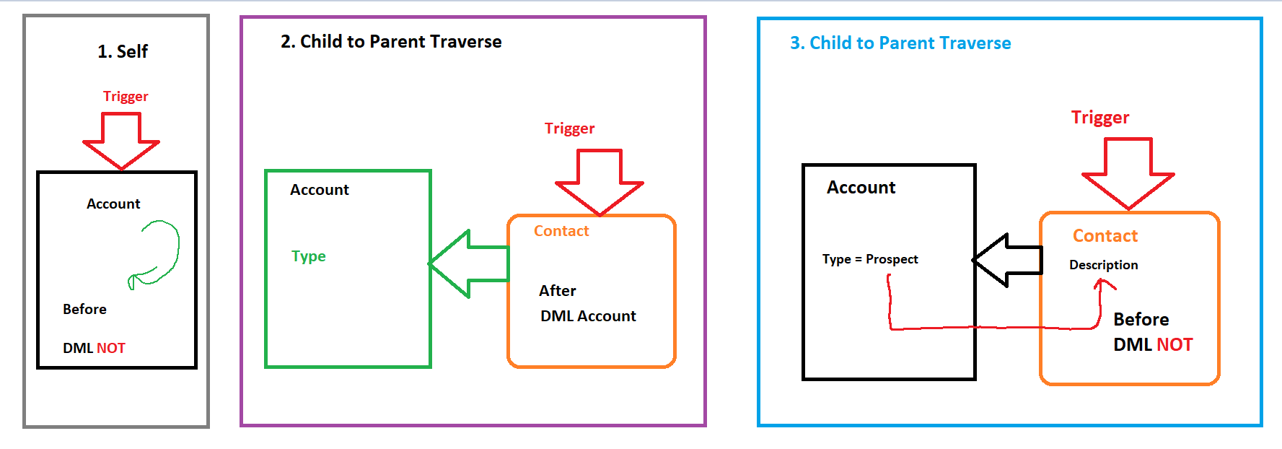



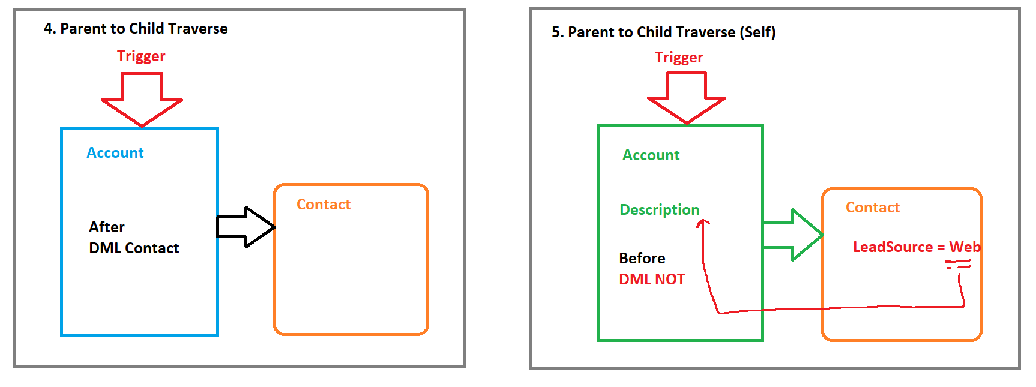

Child to Parent Traverse:

STEPS:

1] Create Set of Parent ID

2] Create Map<ID,ParentObject> 🡪 SQOL over parent for above SET and put the data in MAP.

3] Take Trigger Iteration again and Search key in MAP and apply the appropriate further logic.

Scenario 1] Show latest created/Edited Contact Name on Account Description.

|  |  |  |
| --- | --- | --- |
| Account | Description | Contact |
| Cinemax | C3 | C1 |
| C2 |
| C3 |
|  |  |  |
| Poonam Mall | C300 | C100 |
| C200 |
| C300 |

|  |  |
| --- | --- |
| Event | After |
| Operations | Insert, Update |
| Trigger Object | Contact |
| Affecting Object | Account |

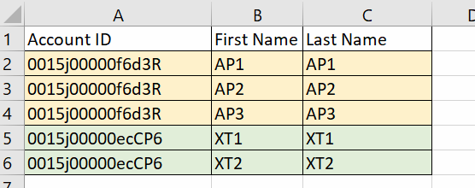

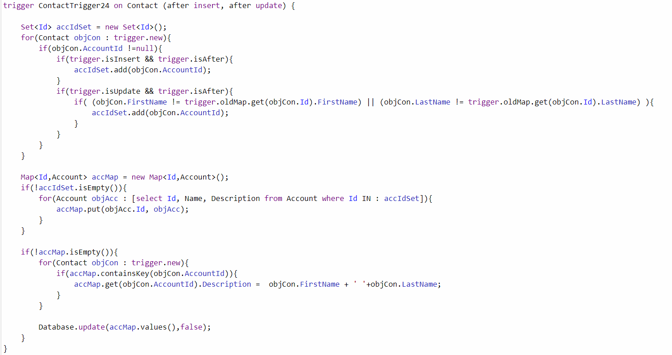



trigger ContactTrigger24 on Contact (after insert, after update) {



Set<Id> accIdSet = new Set<Id>();

for(Contact objCon : trigger.new){

if(objCon.AccountId !=null){

if(trigger.isInsert && trigger.isAfter){

accIdSet.add(objCon.AccountId);

}

if(trigger.isUpdate && trigger.isAfter){

if( (objCon.FirstName != trigger.oldMap.get(objCon.Id).FirstName) || (objCon.LastName != trigger.oldMap.get(objCon.Id).LastName) ){

accIdSet.add(objCon.AccountId);

}

}

}

}

Map<Id,Account> accMap = new Map<Id,Account>();

if(!accIdSet.isEmpty()){

for(Account objAcc : [select Id, Name, Description from Account where Id IN : accIdSet]){

accMap.put(objAcc.Id, objAcc);

}

}

if(!accMap.isEmpty()){

for(Contact objCon : trigger.new){

if(accMap.containsKey(objCon.AccountId)){

accMap.get(objCon.AccountId).Description = objCon.FirstName + ' '+objCon.LastName;

}

}

Database.update(accMap.values(),false);

}

}

=====================================

2] If latest created/Edited Address city is “Nagpur”, then Applicant should be Eligible for Police Verification.

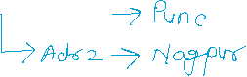

|  |  |
| --- | --- |
| Event | After |
| Operations | Insert, Update |
| Trigger Object | Address |
| Affecting Object | Applicant__c |

trigger AddressTrigger on Address__c (after insert, after update) {

Set<Id> applicantIdSet = new Set<Id>();

for(Address__c objAdr : trigger.new){

if(trigger.isInsert && trigger.isAfter){

applicantIdSet.add(objAdr.Applicant__c);

}

if(trigger.isUpdate && trigger.isAfter){

if(objAdr.City__c != trigger.oldMap.get(objAdr.Id).City__c){

applicantIdSet.add(objAdr.Applicant__c);

}

}

}

Map<Id,Applicant__c> applicantMap = new Map<Id,Applicant__c>();

if(!applicantIdSet.isEmpty()){

for(Applicant__c objApp : [select Id,Police_Verification__c from Applicant__c where Id IN : applicantIdSet]){

applicantMap.put(objApp.Id, objApp);

}

}

if(!applicantMap.isEmpty()){

for(Address__c objAdr : trigger.new){

if(applicantMap.containsKey(objAdr.Applicant__c)){

if(objAdr.City__c == 'Nagpur'){

applicantMap.get(objAdr.Applicant__c).Police_Verification__c = true;

}

else{

applicantMap.get(objAdr.Applicant__c).Police_Verification__c = false;

}

}

}

Database.update(applicantMap.values(),false);

}

}

User Story 3] Create/Edit an Opp, if Amount <=8000 and Stage Name is “Closed Lost”, then Account SLA should be “Silver”. Else, nothing.

|  |  |
| --- | --- |
| Event | After |
| Operations | Insert, Update |
| Trigger Object | Opportunity |
| Affecting Object | Account |

trigger OpportunityTrigger on Opportunity (after insert, after update){

Set<Id> accIdSet = new Set<Id>();

for(Opportunity objOpp : trigger.new){

if(objOpp.AccountId != null){

if(trigger.isInsert && trigger.isAfter){

accIdSet.add(objOpp.AccountId);

}

if(trigger.isUpdate && trigger.isAfter){

if( (objOpp.Amount != trigger.oldMap.get(objOpp.Id).Amount) || (objOpp.StageName != trigger.oldMap.get(objOpp.Id).StageName) ){

accIdSet.add(objOpp.AccountId);

}

}

}

}

Map<Id,Account> accMap = new Map<Id,Account>();

if(!accIdSet.isEmpty()){

for(Account objAcc : [select Id, SLA__c from Account where Id IN : accIdSet]){

accMap.put(objAcc.Id, objAcc);

}

}

if(!accMap.isEmpty()){

for(Opportunity objOpp : trigger.new){

if(accMap.containsKey(objOpp.AccountId)){

if(objOpp.Amount <=8000 && objOpp.StageName =='Closed Lost'){

accMap.get(objOpp.AccountId).SLA__c = 'Silver';

}

else{

accMap.get(objOpp.AccountId).SLA__c = '';

}

}

}

Database.update(accMap.values(),false);

}

}

Assignment:

1] If we create/Edit a Case having Priority as “High” or “Medium”, then Update its related Account Rating as “Hot”. Else nothing

2] If Opp Stage is “Close Won” and Amount> 10000, then Opp LeadSource = “Web”.